**Ultimate Genius**

**Project Report**

Project Work Phase II (ECS899)

Degree

**BACHELOR OF TECHNOLOGY (CSE)**

|  |  |
| --- | --- |
| PROJECT GUIDE:  **Mr. Rupal Gupta**  **(Assitant Professor)** | SUBMITTED BY:  **Udit Gupta (TCA2009044)**  **Sofiya Chaudhary (TCA2009041)**  **Nikunj (TCA2009030)** |
|  |  |

Jan - May, 2024



**FACULTY OF ENGINEERING & COMPUTING SCIENCES**

**TEERTHANKER MAHAVEER UNIVERSITY, MORADABAD**

**DECLARATION**

We hereby declare that this Project Report titled Ultimate Genius submitted by us and approved by our project guide, Faculty of Engineering & Computing Sciences. Teerthanker Mahaveer University, Moradabad, is a bonafide work undertaken by us and it is not submitted to any other University or Institution for the award of any degree diploma / certificate or published any time before.

|  |  |  |
| --- | --- | --- |
| **Project ID :** | Project Id | |
| **Student Name:** | Udit Gupta | Signature |
| **Student Name:** | Sofiya Chaudhary | Signature |
| **Student Name:** | Nikunj | Signature |
|  |  |  |
| **Project Guide :** | Rupal Gupta | Signature |

Table of Contents

1 Project Title 4

2 Problem Statement 4

3 Project Description 5

3.1 Scope of the Work 7

3.2 Project Modules 8

3.3 Context Diagram (High Level) 10

4 Implementation Methodology 11

5 Technologies to be used 12

5.1 Software Platform 12

5.2 Hardware Platform 12

5.3 Tools, if any 12

6 Advantages of this Project 14

7 Assumptions, if any 13

8 Future Scope and further enhancement of the Project 17

9 Project Repository Location 19

10 Definitions, Acronyms, and Abbreviations 19

11 Conclusion 19

12 References 21

**Appendix**

**A: Data Flow Diagram (DFD)**

**B: Entity Relationship Diagram (ERD)**

**C: Use Case Diagram (UCD)**

**D: Data Dictionary (DD)**

**E: Screen Shots**

# Project Title – Ultimate Genius

# Problem Statement

# In educational settings such as schools and colleges, assessing students' comprehension of subjects is a fundamental aspect of the learning process. However, traditional testing methods often fall short in accurately gauging students' understanding and can be perceived as monotonous by both educators and learners. These conventional tests may not effectively capture the depth of knowledge and skills possessed by students, thereby hindering the ability to provide targeted feedback and support for improvement.

# To address these challenges, there is a pressing need for innovative solutions that enhance the assessment process, providing educators with better insights into students' grasp of the material while also engaging learners in a more dynamic and interactive manner. One such solution is the development of a quiz application tailored specifically for educational environments.

# The proposed project aims to tackle this problem by creating a quiz app that offers a more dynamic and efficient means of assessing students' understanding of subjects. This app will empower teachers to design and administer quizzes that are customized to their curriculum and instructional objectives. Through the use of special codes, teachers can easily distribute these quizzes to their students, who can then access and complete them online at their convenience.

# Project Description

The project entails the development of a comprehensive quiz application designed to streamline the process of creating, distributing, and grading quizzes for educational purposes. Targeted towards both teachers and students, the app aims to revolutionize traditional methods of assessment by offering a more engaging and interactive platform for learning and testing.

**Key Features:**

* Quiz Creation: Teachers are provided with intuitive tools within the app to create quizzes covering a wide range of subjects and topics. These quizzes can be customized to align with specific learning objectives, curriculum standards, and instructional preferences. Teachers have the flexibility to incorporate various question types, including multiple choice, true/false to effectively assess student understanding.
* Quiz Storage: The app serves as a centralized repository for storing quizzes created by teachers. Quizzes are organized categorically, making it easy for educators to locate and manage their questions. This feature ensures that quizzes are readily accessible whenever needed, eliminating the hassle of maintaining physical copies or digital files across multiple platforms.
* Quiz Distribution: Teachers can effortlessly share quizzes with their students using unique codes generated by the app. These codes serve as access keys, allowing students to retrieve and take the assigned quizzes online. This streamlined distribution process simplifies quiz administration and ensures equitable access for all students, regardless of their physical location or access to traditional classroom resources.
* Online Quiz Taking: Students can access assigned quizzes through the app by entering the corresponding special codes provided by their teachers. They can then complete the quizzes online at their convenience, using any internet-enabled device such as smartphones, tablets, or computers. This flexibility empowers students to engage in self-paced learning and assessment, fostering a more personalized educational experience.
* Automatic Grading: Upon submission of a quiz, the app automatically grades the responses and generates comprehensive results for both students and teachers in real-time. This feature eliminates the need for manual grading, saving valuable time for educators and providing immediate feedback to students.

## Scope of the Work

* **Development of a web-based quiz application**: We create a website where teachers and students can log in to access quizzes.
* **Creation of teacher and student portals**: We design separate sections for teachers and students, each with their own login pages and features.
* **Functionality for teachers to generate quizzes and store them in quiz banks:** Teachers can make quizzes with different questions and save them in the app for later use.
* **Capability for teachers to share quiz codes with students:** Teachers can share special codes with their students, allowing them to access specific quizzes.
* **Student access to quizzes using provided codes:** Students can use the codes given by their teachers to open and take the quizzes online.
* **Automated result sharing with both students and teachers**: Once a student completes a quiz, the app will automatically send the results to both the student and the teacher, making it easy to track progress.

## Project Modules

* **User Management:**
* **Registration**: Teachers and students will have to register with the quiz application by providing their basic information such as name, email, and password.
* **Login**: Once registered, users can log in securely using their credentials.
* **Authentication**: The application will verify the identity of users during login to ensure only authorized users can access their accounts.
* **Quiz Bank Management:**
* **Creation**: Teachers will be able to create new quiz banks and assign them to specific subjects or topics.
* **Editing**: Teachers can modify existing quiz banks by adding, removing, or editing questions.
* **Organization**: Quiz banks will be organized in a structured manner, making it easy for teachers to find and manage their quizzes efficiently.
* **Quiz Generation:**
* **Selection**: Teachers can select questions from the existing quiz banks to create custom quizzes.
* **Customization**: They can customize the quizzes by choosing the number of questions, difficulty level, and other parameters.
* **Preview**: Before finalizing, teachers can preview the quiz to ensure its accuracy and suitability.
* **Quiz Taking**:
* **Code Entry:** Students will enter specific codes provided by their teachers to access the assigned quizzes.
* **Quiz Interface**: Once the code is entered, students will be directed to the quiz interface where they can view and attempt the questions.
* **Submission**: After completing the quiz, students will submit their answers for evaluation.
* **Result Management**:
* **Storage**: The application will store the quiz results securely, associating them with the respective quizzes and users.
* **Distribution**: Results will be automatically distributed to both students and teachers upon completion of the quiz.
* **Analysis**: Teachers can analyze the results to assess students' performance and identify areas for improvement.

## Context Diagram

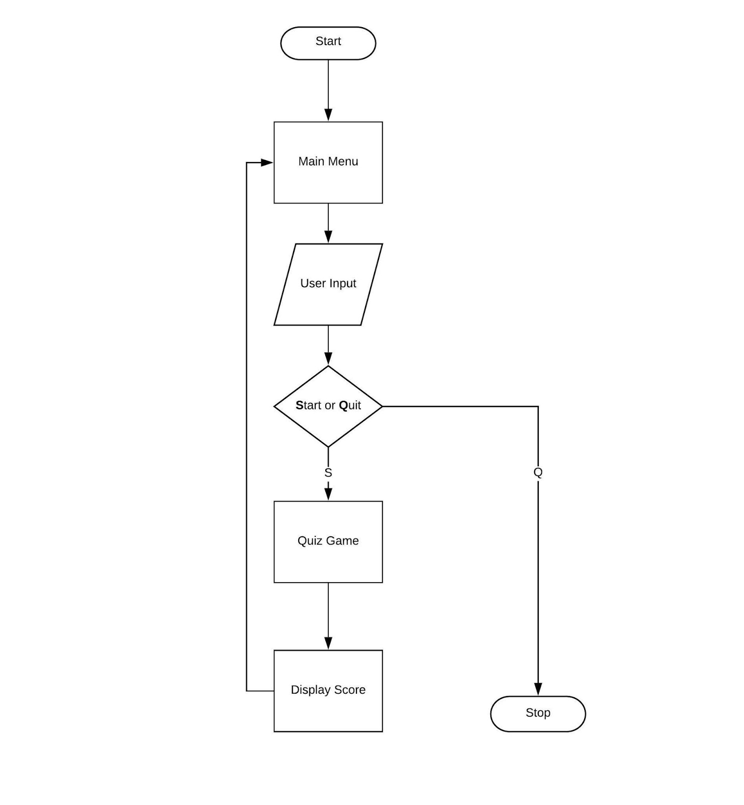

# Implementation Methodology

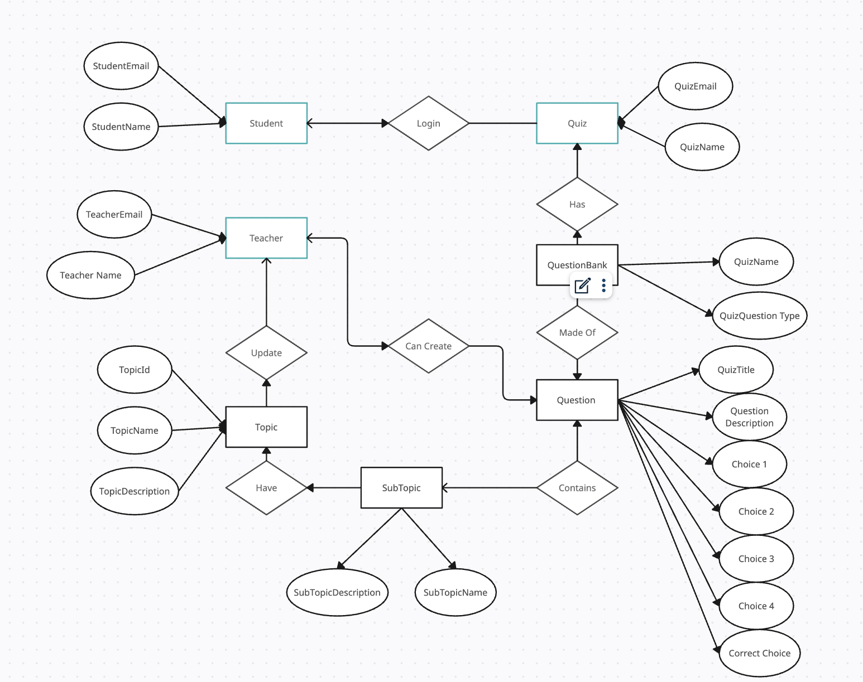

# Technologies to be used

## Software Plat form

1. **Front-end –** ReactJS

ReactJS, developed by Facebook, is a popular JavaScript library for building user interfaces. It provides a component-based architecture, allowing developers to create reusable UI components and compose them to build complex user interfaces efficiently. ReactJS utilizes a virtual DOM (Document Object Model) for optimal performance, enabling fast rendering of UI components and seamless updates without reloading the entire page.

**Key Features of ReactJS:**

* Component-based Architecture: ReactJS facilitates the creation of reusable UI components, promoting code reusability and maintainability.
* Virtual DOM: ReactJS employs a virtual DOM to efficiently update the UI, minimizing DOM manipulation overhead and enhancing performance.
* JSX Syntax: ReactJS utilizes JSX (JavaScript XML) syntax, enabling developers to write HTML-like code within JavaScript files, which enhances readability and simplifies UI development.
* Unidirectional Data Flow: ReactJS follows a unidirectional data flow architecture, ensuring predictable state management and facilitating debugging and testing of applications.
* Rich Ecosystem: ReactJS boasts a vibrant ecosystem of libraries, tools, and community-driven resources, providing developers with extensive support and flexibility for building diverse web applications.

1. **Back-end –** NodeJs, Mongoose, Express

Node.js is a runtime environment that allows developers to execute JavaScript code on the server-side. It offers an event-driven, non-blocking I/O model, making it well-suited for building scalable and high-performance server-side applications. Express.js is a minimalist web framework for Node.js, providing a robust set of features for building web servers and APIs quickly and efficiently. Mongoose is an Object Data Modeling (ODM) library for MongoDB and Node.js, simplifying the interaction with MongoDB databases by providing a schema-based solution.

Key Features of Node.js, Express, and Mongoose:

* Non-blocking I/O: Node.js utilizes an event-driven, non-blocking I/O model, enabling asynchronous processing of requests and optimal resource utilization.
* Scalability: Node.js is highly scalable, capable of handling a large number of concurrent connections with minimal overhead, making it ideal for building real-time applications and microservices architectures.
* Middleware Support: Express.js offers middleware support, allowing developers to modularize application logic and enhance code maintainability and extensibility.
* Database Integration: Mongoose simplifies database interactions in Node.js applications by providing a schema-based solution, data validation, and support for complex querying and data manipulation operations.
* RESTful API Development: Express.js facilitates the development of RESTful APIs, providing a flexible and intuitive routing mechanism, middleware support, and HTTP request handling capabilities.
* Community Support: Node.js, Express.js, and Mongoose benefit from large and active developer communities, offering extensive documentation, tutorials, and third-party libraries/plugins for building diverse web applications and services.

## Hardware Platform

RAM, Hard Disk, OS, Editor, Browser etc.

# Advantages of Project

* **Enhanced Engagement**: A quiz application offers an interactive and engaging learning experience for both teachers and students, fostering active participation and interest in the educational process.
* **Efficient Assessment**: By digitizing the assessment process, teachers can create quizzes quickly and efficiently, saving time and effort compared to traditional paper-based methods.
* **Immediate Result**: With automated result sharing, students receive instant feedback on their performance, allowing them to identify areas of strength and weakness in real-time.
* **Convenient Access:** The web-based nature of the quiz application allows users to access quizzes from anywhere with an internet connection, providing flexibility and convenience for both teachers and students.
* **Customization Options**: Teachers can customize quizzes to suit the specific needs and learning objectives of their students, tailoring questions to different skill levels and topics.
* **Organized Quiz Banks**: The ability to create and manage quiz banks facilitates better organization of assessment materials, making it easier for teachers to find and reuse questions for future quizzes.
* **Email Verification**: Implementing email verification during the registration process adds an extra layer of security and ensures that users provide valid email addresses, reducing the risk of unauthorized access to the system.
* **User Validation**: Before allowing users to access the system, the quiz application can verify their credentials, ensuring that only valid users with authorized access can log in and use the platform.
* **Data Security**: By implementing user validation and email verification, the quiz application enhances data security, protecting sensitive information and preventing unauthorized access to user accounts.
* **Scalability**: As the user base grows, the quiz application can easily scale to accommodate more users and quizzes, ensuring continued functionality and performance even with increasing demand.
* **Analytics and Insights**: The application can track user activity and performance over time, providing valuable analytics and insights to teachers and administrators for informed decision-making and instructional planning.
* **Enhanced Learning Experience**: Overall, a quiz application contributes to a more dynamic and interactive learning experience, promoting student engagement, improving assessment accuracy, and supporting continuous learning and improvement.

# Future Scope and further enhancement of the Project

* **Integration with Learning Management Systems (LMS)**: Integrate the quiz application with popular learning management systems such as Moodle or Canvas to streamline the process of creating, managing, and delivering quizzes within existing educational platforms.
* **Advanced Analytics and Reporting:** Enhance the application with advanced analytics tools to provide detailed insights into student performance, including question-level analysis, time spent on each question, and performance trends over time. This can help teachers identify areas for improvement and tailor instructional strategies accordingly.
* **Gamification Features:** Incorporate gamification elements such as badges, and rewards to make the quiz-taking experience more engaging and motivating for students, encouraging healthy competition and participation.
* **Multimedia Support**: Expand the capabilities of the quiz application to support multimedia content such as images, videos, and audio files within quiz questions and answers, allowing for more interactive and immersive learning experiences.
* **Accessibility Features**: Ensure that the quiz application is accessible to all users, including those with disabilities, by implementing features such as screen reader compatibility, keyboard navigation, and alternative text for multimedia content.
* **Mobile Compatibility**: Develop mobile-friendly versions of the quiz application to enable access from smartphones and tablets, providing users with the flexibility to take quizzes on-the-go.
* **Collaborative Quizzing:** Introduce features that enable collaborative quizzing, allowing multiple students to participate in group quizzes and discussions, fostering teamwork and peer learning.
* **Adaptive Quizzing**: Implement adaptive quizzing algorithms that dynamically adjust the difficulty level of questions based on each student's performance, ensuring personalized learning experiences tailored to individual needs and abilities.
* **Integration with External Content Providers:** Partner with educational content providers to integrate their resources seamlessly into the quiz application, giving teachers access to a wide range of high-quality educational materials to create quizzes from.
* **Continuous Support and Updates:** Provide ongoing technical support and regular updates to the quiz application to address user feedback, fix bugs, and introduce new features and enhancements based on evolving educational needs and technological advancements.

# Project Repository Location

| **S#** | **Project Artifacts (softcopy)** | **Location** (Mention Lab-ID, Server ID, Folder Name etc.) | **Verified by Project Guide** | **Verified by Lab In-Charge** |
| --- | --- | --- | --- | --- |
|  | Project Synopsis Report (Final Version) |  |  |  |
|  | Project Progress updates |  |  |  |
|  | Project Requirement specifications |  |  |  |
|  | Project Report (Final Version) |  |  |  |
|  | Test Repository |  |  |  |
|  | Project Source Code (final version) with executable |  |  |  |
|  | Any other document |  |  |  |

# Conclusion

In conclusion, the development of the quiz application represents a significant step forward in enhancing the educational experience for both teachers and students. By leveraging technology to create an interactive and engaging platform for quiz creation, distribution, and assessment, the application addresses key challenges faced in traditional educational settings. The introduction of features such as user registration, login, and authentication ensures secure access to the system, while email verification and user validation add an extra layer of security and authenticity.

The application's user-friendly interface and intuitive functionalities make it easy for teachers to create quizzes, organize them into quiz banks, and share them with students using unique codes. Students, in turn, benefit from convenient access to quizzes, immediate feedback on their performance, and the flexibility to engage in learning activities from anywhere with an internet connection.

Furthermore, the integration of advanced features such as analytics and reporting, gamification elements, multimedia support, and mobile compatibility enhances the overall learning experience, promoting student engagement, motivation, and academic success. The application's scalability, adaptability, and continuous support and updates ensure its long-term viability and relevance in meeting the evolving needs of the educational landscape.

In summary, the quiz application represents a valuable tool for educators seeking to create dynamic and interactive learning environments, promote active learning and assessment practices, and support student achievement and growth. With its comprehensive features, user-friendly interface, and commitment to innovation and improvement, the quiz application is poised to make a significant impact on the educational experience of teachers and students alike.

# References

|  |  |  |  |  |
| --- | --- | --- | --- | --- |
| **S#** | **Reference Details** | **Owner** | **Version** | **Date** |
|  | Project Synopsis |  |  |  |
|  | Project Requirements |  |  |  |
|  |  |  |  |  |

**Annexure A**

**Data Flow Diagram (DFD) – Level 0**

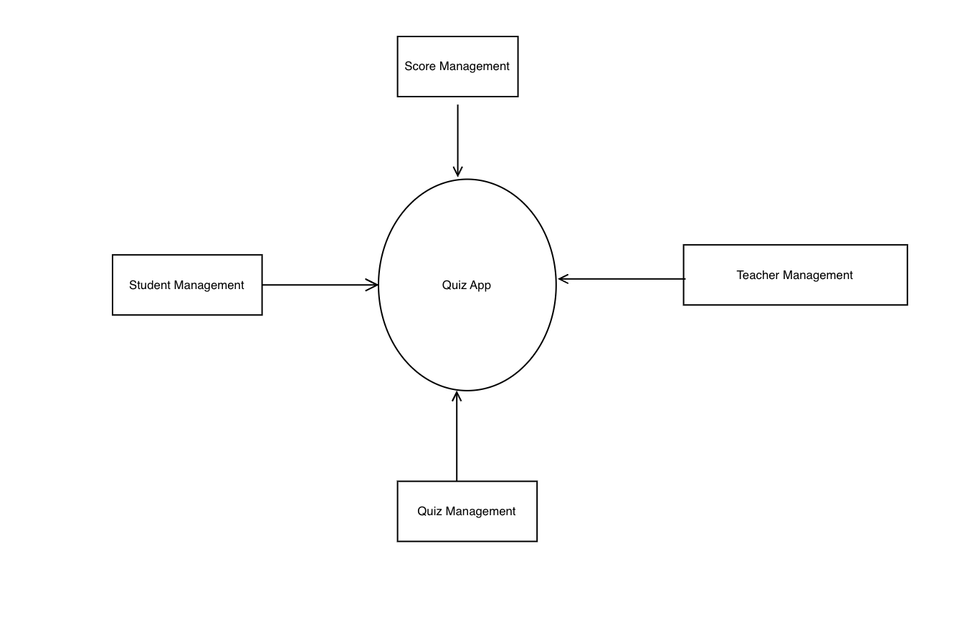

**Data Flow Diagram**

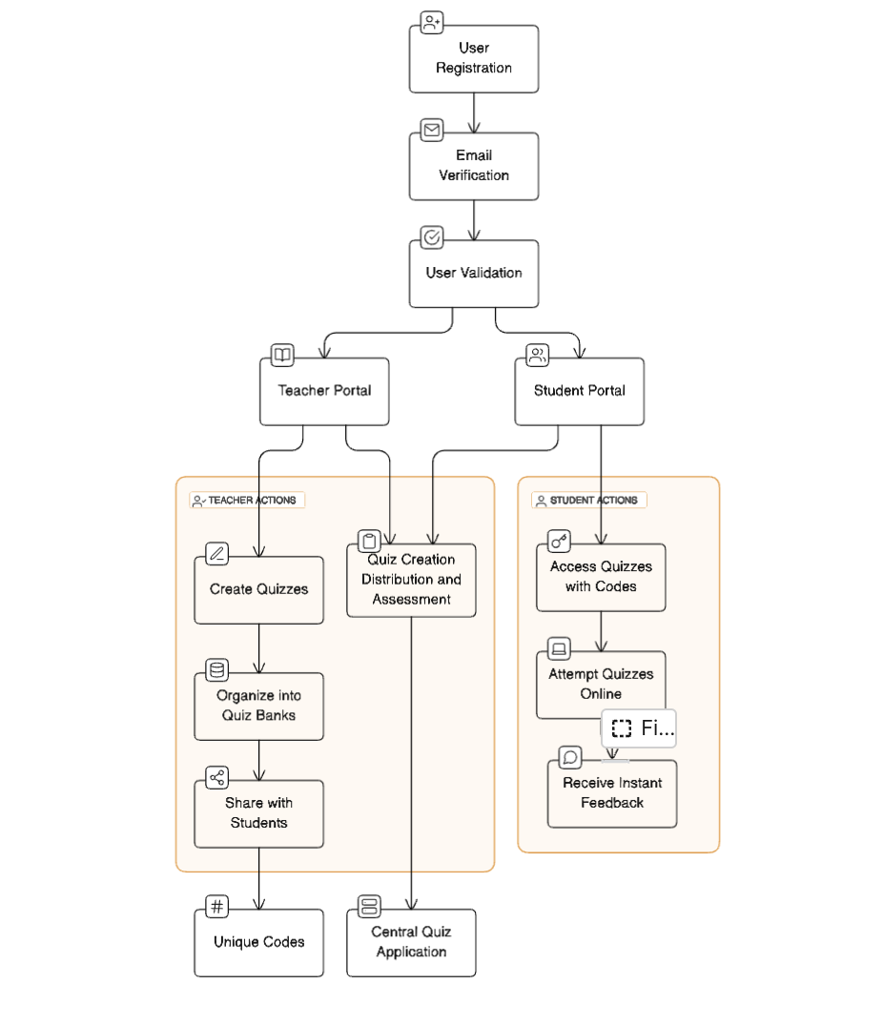

**Annexure B**

**Entity-Relationship Diagram (ERD)**



**Annexure D**

**Data Dictionary (DD)**

**Example:**

**User Table (USR)**

|  |  |  |
| --- | --- | --- |
| **Fields** | **Data type** | **Description** |
| USR-Name |  |  |
| USR-Password |  |  |
| USR-Contact-No |  |  |
| USR-Address |  |  |

**Supplier Table (SUPP)**

|  |  |  |
| --- | --- | --- |
| **Fields** | **Data type** | **Description** |
| SUPP-ID |  |  |
| SUPP-Name |  |  |
| SUPP-Address |  |  |
| SUPP-Contact |  |  |
| SUPP-Credit-Limit |  |  |

**Annexure E**

**Screen Shots**

**Home Page:**

